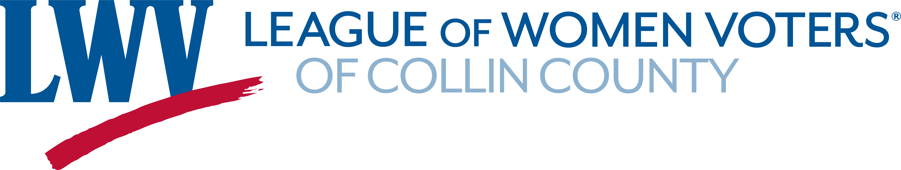
Observer Report Form

Member name:
Government body:
Meeting date:

Summary:

Were any of the topics relevant to LWV positions or programs?

Additional comments:

Please send this form to lwvcollin@gmail.com.

Thank you for attending this meeting on behalf of LWV-CC!

