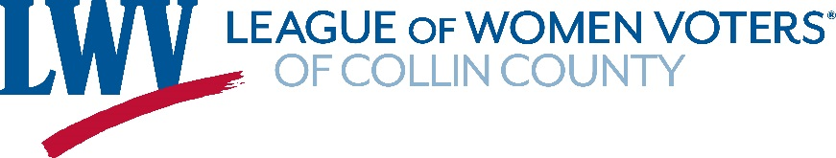

Request for Candidate Forum Assistance

Sponsoring Organization:
Contact name:
Contact email:
Contact phone:
Organization name:
Organization website:
Is the organization nonpartisan – i.e., the organization does not support or oppose a political party or candidate, and is not affiliated with a ballot issue? ( Y / N )

Event:
Event name/purpose:
Event date/time:
Event location:
Expected number of event attendees:
Which candidates/offices are invited?
Is the event nonpartisan – i.e., all candidates for the offices are invited? ( Y / N )

Type of assistance requested from LWV-CC: __ Guidance or __ Volunteers
- Guidance: LWV-CC provides sample guidelines and sample moderator script, but does not provide volunteers at the forum.

- Volunteers: LWV-CC provides volunteers such as moderator, timekeeper, and question screeners, as well as guidelines, moderator script, candidate speaking order, and extra questions.

Forum sponsors must adhere to the LWV-CC Candidate Forum Assistance Agreement available on the LWV-CC Forums webpage.

Please submit this request to lwvcollin@gmail.com, or contact us with any questions.

Thank you!

